**AWS-LIGHTSAIL**

* If you want to setup and create a virtual private servers which already has everything installed

Example: wordpress, gitlab, node.js, joomla,drupal,Django

* No Auto-Scaling available
* Amazon LightSail is an easy way for developers to get started with a simple virtual private server (VPS) solution
* LightSail provides compute, storage, and networking capacity and capabilities to deploy and manage websites and web applications in the cloud
* LightSail includes everything you need to launch your project quickly- a virtual machine, SSD-based storage, data transfer, DNS management, and a static IP.
* LightSail is best suited to projects that require a few virtual private servers and users who prefer a simple management interface.
* Common use cases for LightSail include running websites, web applications, blogs, e-commerce sites, simple software, and more
* LightSail offers a range of operating system and application templates that are automatically installed when you create a new LightSail instance. Application templates include WordPress, Drupal, Joomla!,Magento,Redmine,LAMP,Niginx(LEMP),MEAN,Node.ja,and more
* LightSail is available in 44 availability zones and 16 regions globally
* A LightSail plan includes a virtual server with a fixed amount of memory (RAM) and compute (vCPUs), SSD- based storage (disk), and free data transfer allowance. LightSail plans aloo offer static IP address (5 per account) and DNS management (3 domain zones per account). LightSail plans are charged on an hourly, on-demand basis, so you only pay for a plan when you're using it.
* Everything that you do from the LightSail console can also be done with an API call
* Each LightSail instance automatically gets a private IP address and public IP address, which are reachable from the internet. You can use the private IP to send data to other LightSail instances and AWS resources in private, for free you can also substitute the public IP of a LightSail instance with a static IP.
* With LightSail, you can also map your registered domain manes such as example.com to the public IPs of your LightSail instances.
* To use a domain in LightSail, you must first register it. This can be done using Route53
* Snapshots can be used to back up your data within LightSail. These snapshots can be used to create a new LightSail instance.
* Each LightSail plan comes with a free data transfer allowance.

**AWS – LightSail Dash Board**

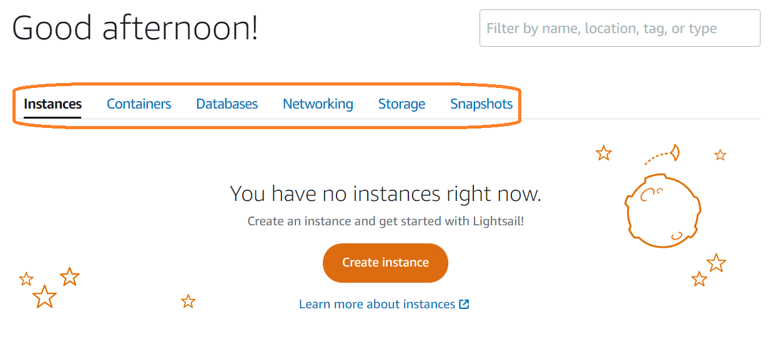

Default Availability zone **ap-south-1a**

Light does not integrate any other third-party tools/software

We should call LightSail instance should not call EC2 instance

Add Launch scripts same as **user data scripts in EC2 instance**

LightSail will support docker images

LightSail will support only 2 databases one is **PostgreSQL, MySQL**

Instance plan 🡪 First 3 months it will be free

We don’t get big storage in LightSail maximum storage will be 32 GB

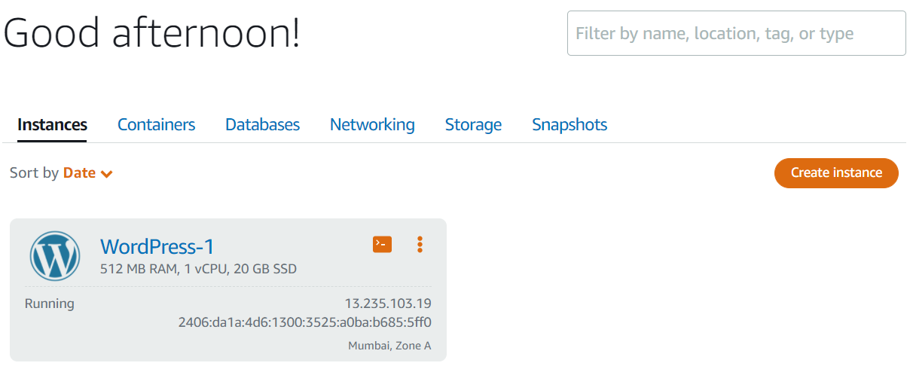

Click on Connect

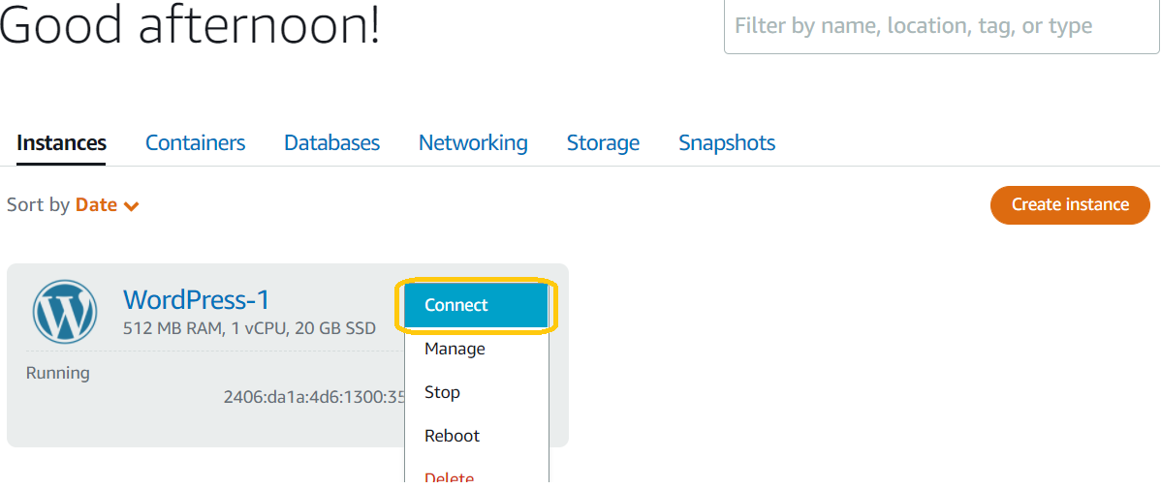

LightSail console

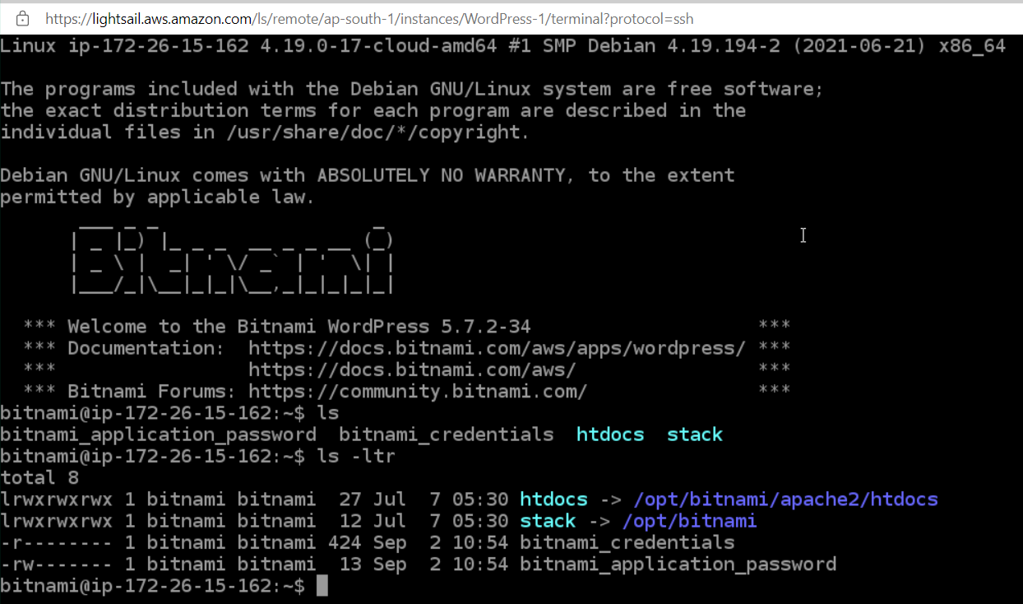

Right Click and Delete